QUESTIONS (Programs) -
-------------------

QUESTION 1:

Description: Write Java program to allow the user to input his/her age.
Then the program will show if the person is eligible to vote.
A person who is eligible to vote must be older than or equal 1 to 18 years old.

Program & Output :-

CASE 1 : (if eligible to vote) -

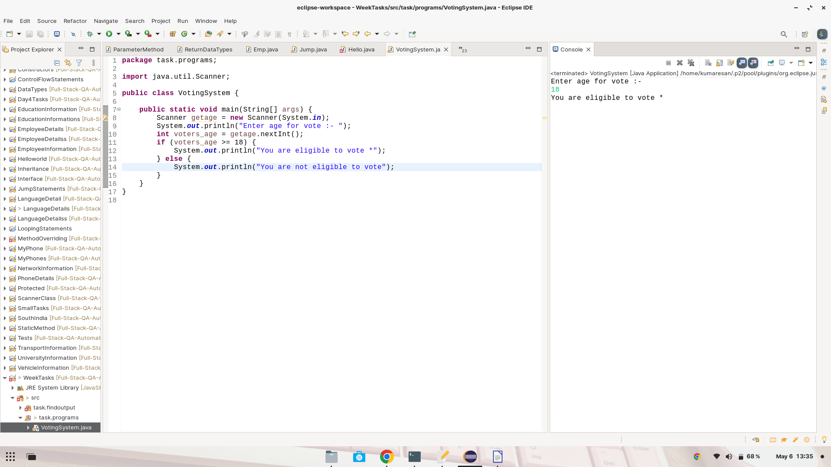

CASE 2 : (if not eligible to vote) -

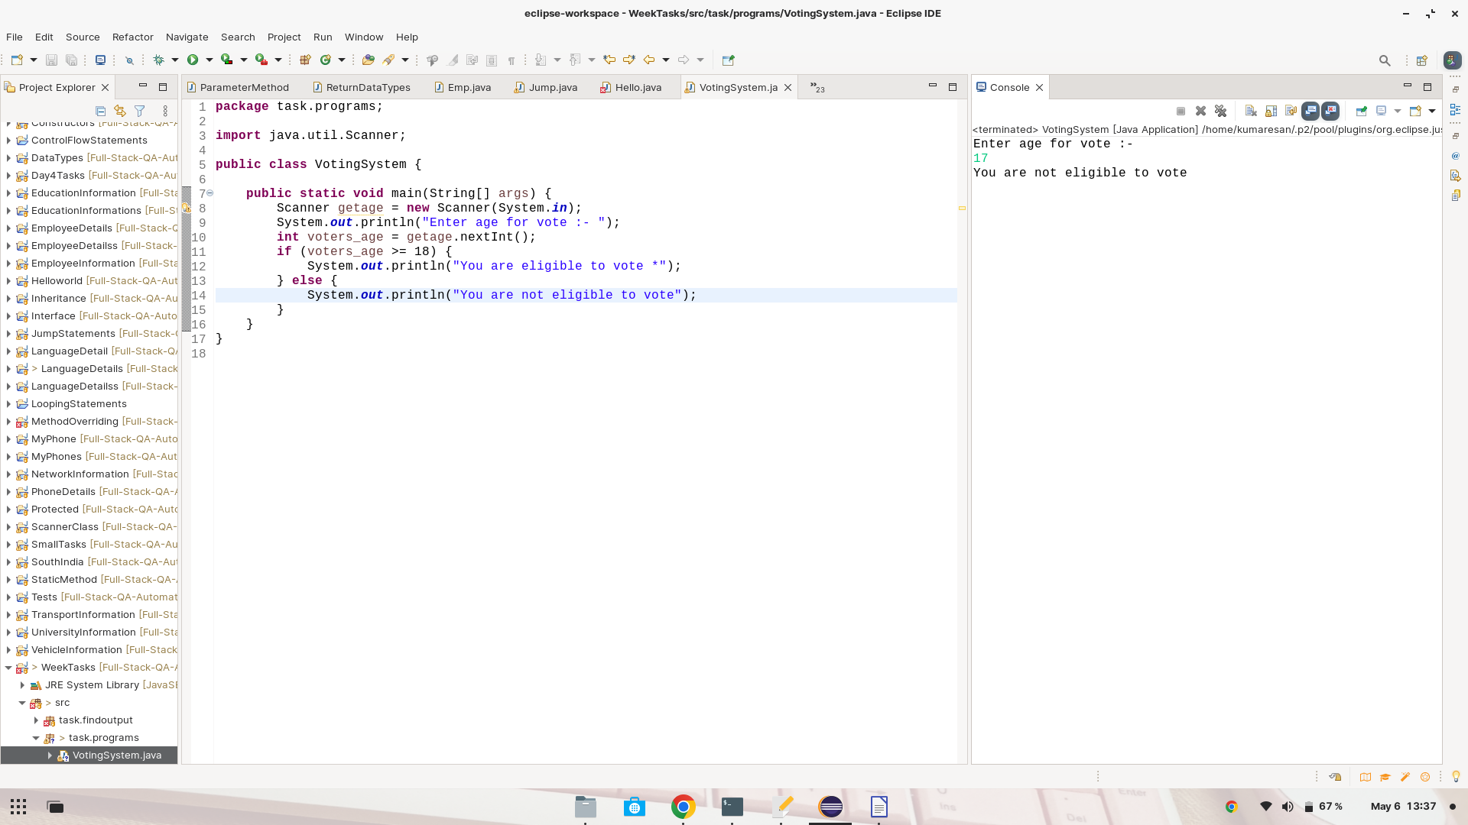
------------------------------------------------------------------
QUESTION 2:
-----------
Description: Write a program to find even or odd number

Program & Output :-

CASE 1 : (if even number) -
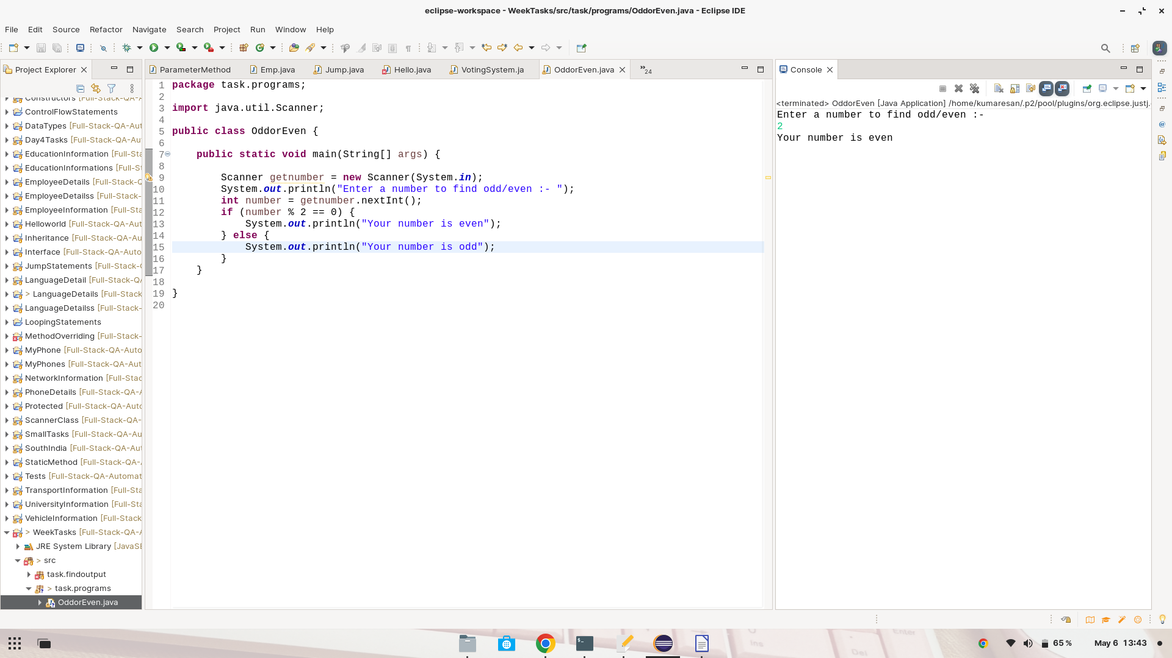

CASE 2 : (if odd number) -

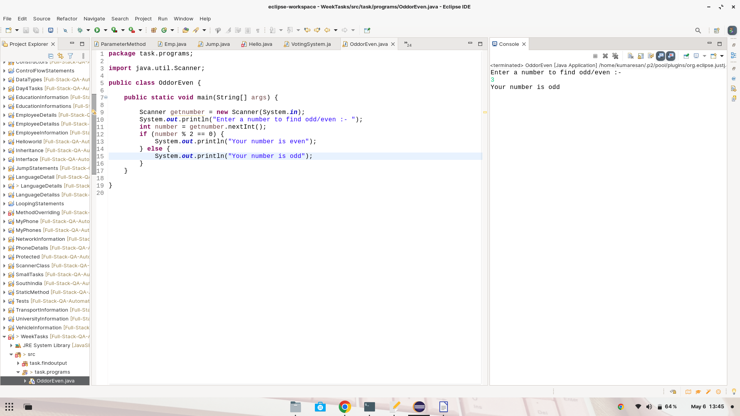

QUESTION 3:
------------
Description: Write a program to print even number from 1 to 100

Program & Output :-

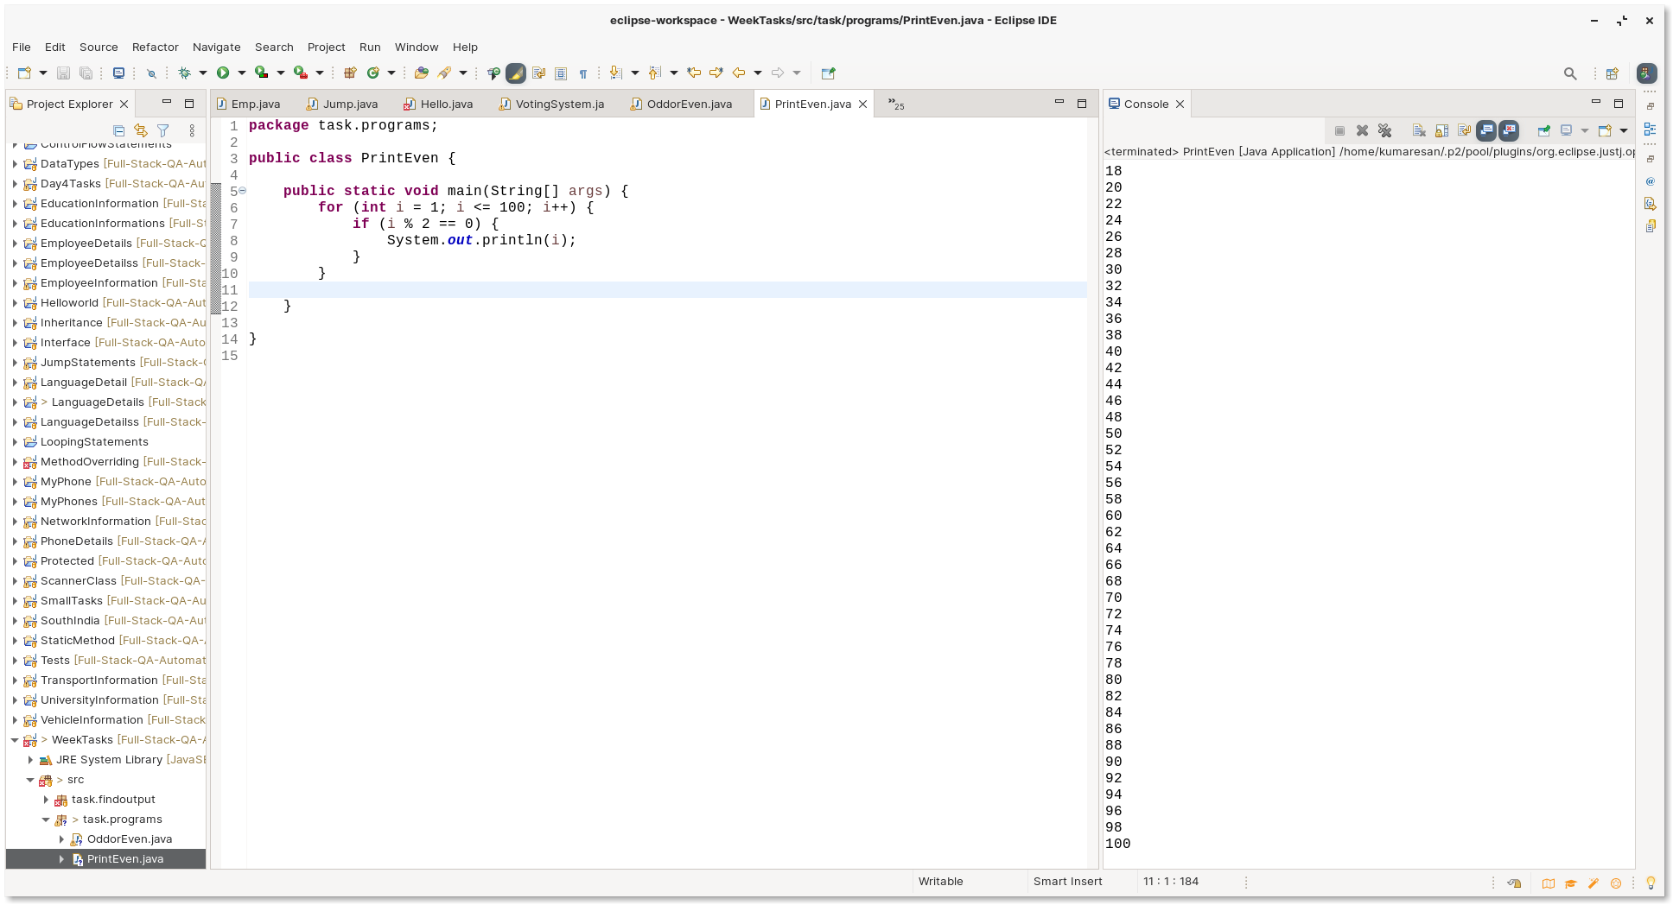
QUESTION 4:
------------
Description: Find the sum of odd number 1 to 100
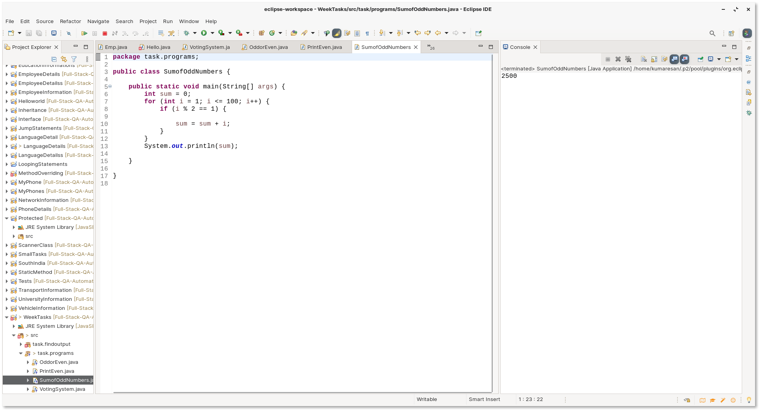
Program & Output :-

QUESTION 5:
-----------
Description: Count of even number 1 to 100
Program & Output :-
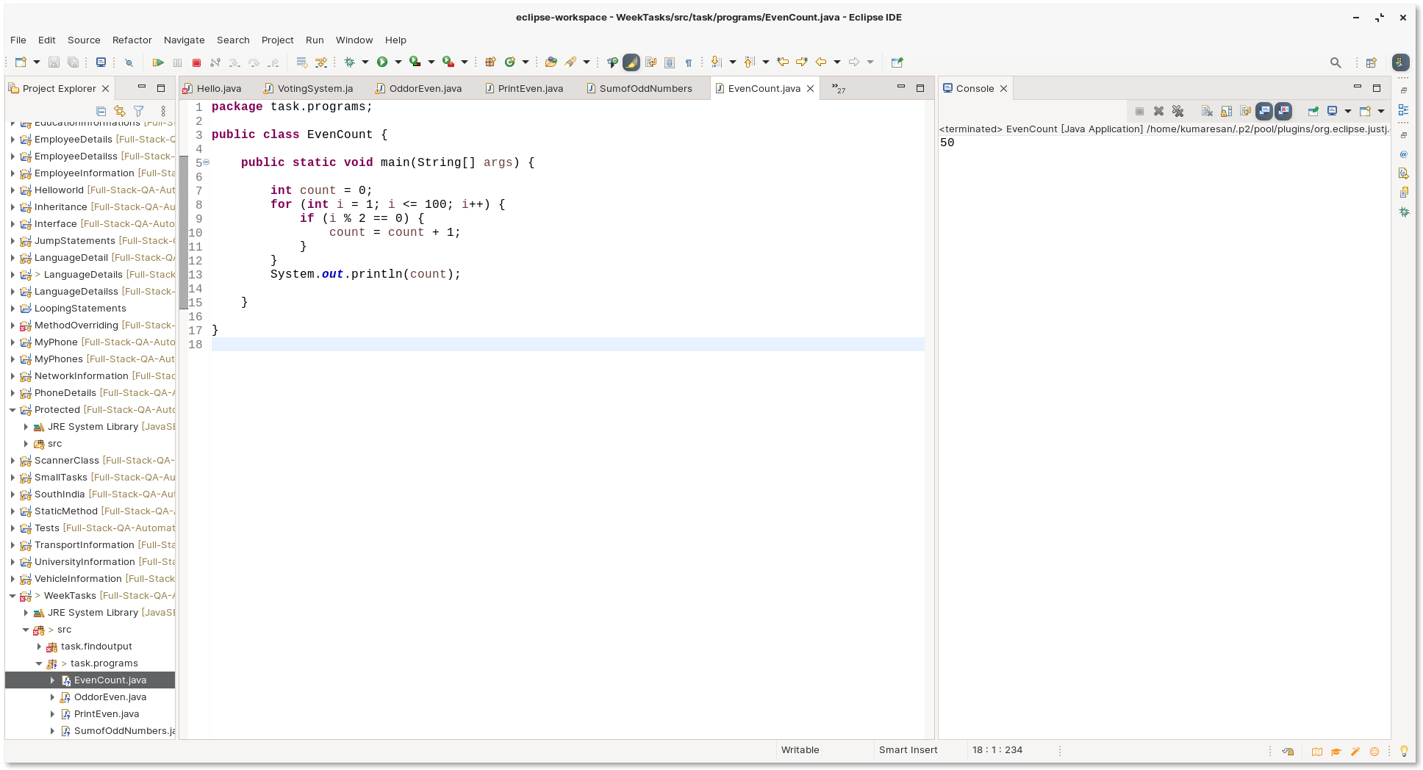
QUESTION 6:
-----------
Description: Write a program to find the factorial of a number.

Program & Output :-

